

Portal File Attachment Service

Project Implementation

Integration Kit Design

# Table of Contents

Table of Contents 2

Overview 3

Design 4

Implementation 4

Request 4

Response 4

Configuration 4

Dependencies 5

Persistence 5

Presentation 6

Logic 7

# Overview

As part of the Turnstile Kit a new service will be added to AgencyPortal. This service can be seen highlighted in yellow in Figure 1.



Figure

# Design

The primary responsibility of this service is take in multiple PDF/TIFF files and attach them to a work item. The medium that will be used to transfer this data is a MIME multi-part form-data message over HTTP. The end result will be multiple new file attachment records stored in the database and associated with an existing work item. These file attachments should be viewable on the portal data entry pages.

# Implementation

## Request

The HTTP request is broken down into multiple parts:

* Two form-data parts:
  + WORKITEMID : The ID of the work item created by Upload Writer.
  + TRANSACTION_NAME : The Transaction Definition ID returned by Upload Writer.
* Multiple file attachment parts:
  + Filename : is the unique name of the attached file
  + ContentType : is the type of content (usually “application/pdf”)

## Response

The HTTP response is a simple text response containing XML. The XSD structure is shown below:

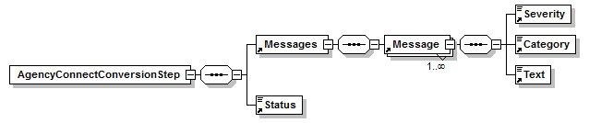

## Configuration

A new servlet will be added and configured in web.xml:

<servlet>

<description>Attaches Files to Work Item</description>

<display-name>File Attachment Servlet</display-name>

<servlet-name>FileAttachmentServlet</servlet-name>

<servlet-class>com.agencyport.shared.servlets.FileAttachmentServlet</servlet-class>

</servlet>

<servlet-mapping>

<servlet-name>FileAttachmentServlet</servlet-name>

<url-pattern>/FileAttachmentServlet</url-pattern>

</servlet-mapping>

## Dependencies

The new servlet is dependent on Appache’s commons-fileupload utilities and core AgencyPortal utilities as shown below:

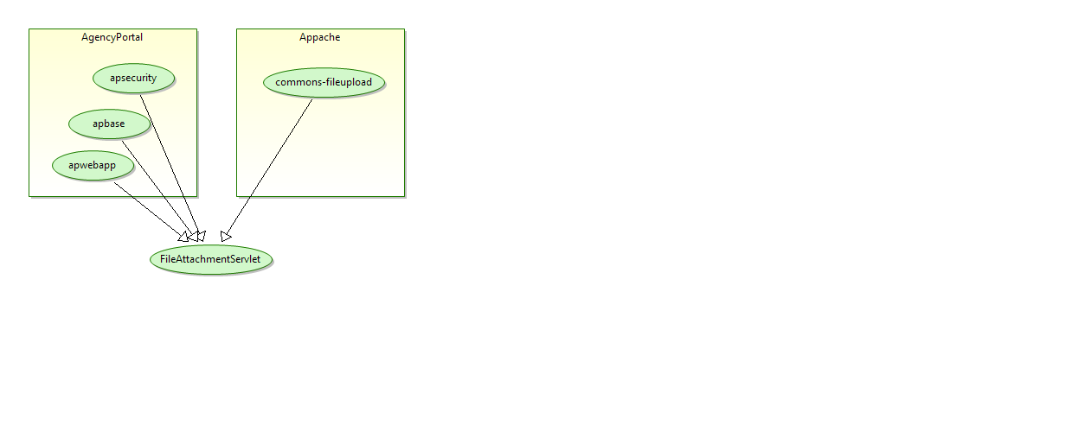

## Persistence

The servlets duties are to store the file parts of the MIME message into a configurable database table. The table can be either WORK_ITEM_ASSISTANT_FILE_ATT or FILEATTACHMENT. It makes this decision based on whether the work item assistant is enabled (See [Dev-Zone](https://dev.agencyport.com/) on how to enable).

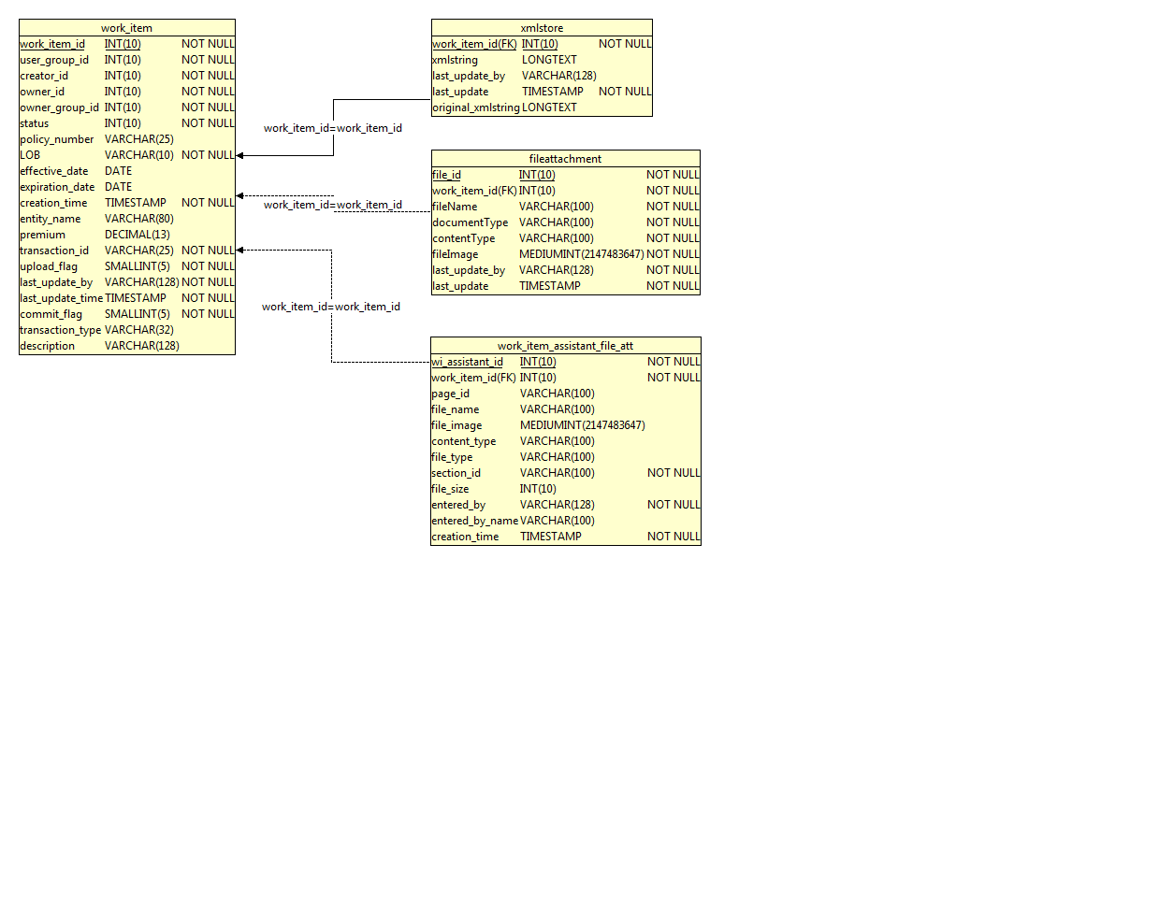

For the FILEATTACHMENT table the APDataCollection has to updated in XMLSTORE table with the elements shown below:

<FileAttachmentInfo>

<AttachmentTypeCd>COI</AttachmentTypeCd>

<AttachmentFilename>Policy.pdf</AttachmentFilename>

</FileAttachmentInfo>

## Presentation

These files will be shown to the user on the File Attachment screen as indicated below:

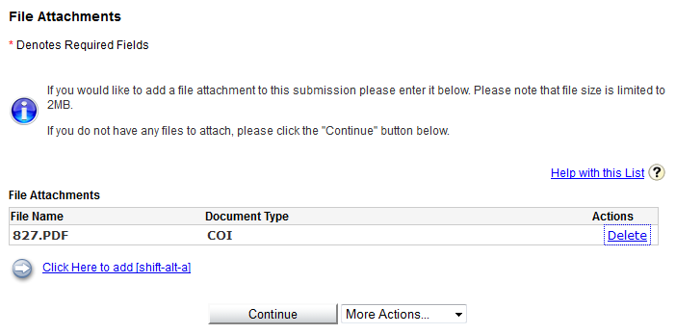

## 

## Logic

The sequence diagram below shows an attachment being stored in the Work Item Assistant table:

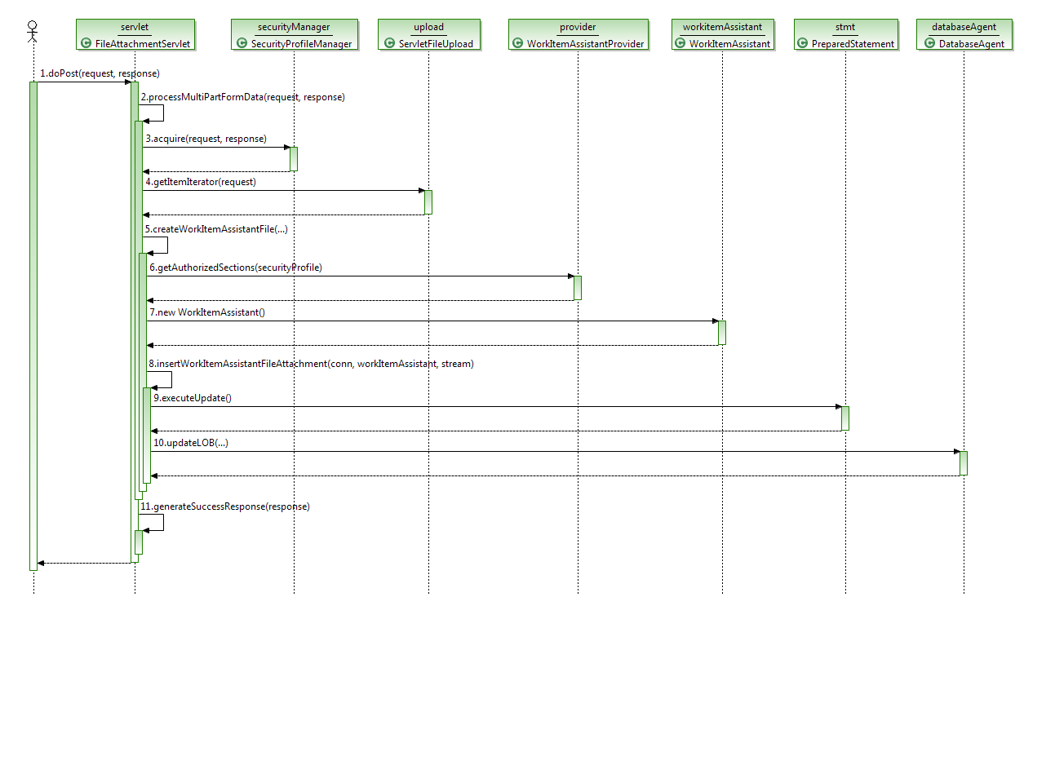

The sequence diagram below shows what happens when the documents are stored in the File Attachment table and the AP Data Collection is updated in the XML Store table:

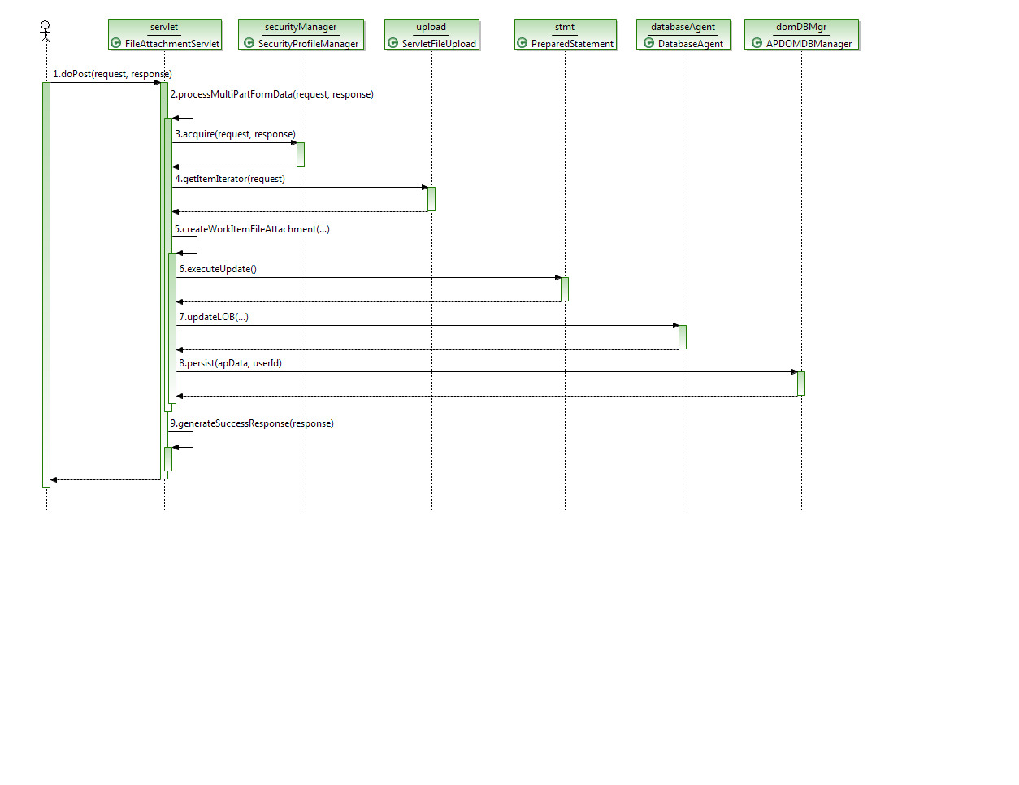

### Configuration

The following properties should be configured to change how files are attached to the work item.

|  |  |  |
| --- | --- | --- |
| **Property** | **Default** | **Description** |
| fileattachment_default_type | COI | Designates the file type to select from available options. |
| workitem_assistant_supported | false | Designates whether to store file as a work assistant section or transaction page. |